**TnP Question Bank for the forthcoming batches** (upload at – bit.ly/QuesBank18)

You are requested to mention the following details in the best possible manner for the junior batches to have an upper hand during their placements. Pls feel free to add any other sections that you deem fit.

**Name –** Siddharth Gupta **Enrolment No.** - 9915103236 **Batch** – F7

**Contact No. –** 9654778453 **Company’s Name and Profile** - Infosys

**Technical Questions**:

Q1) What is a Datatype?

Q2) Why do we need to classify different objects/variable into different datatypes?

Q3) What are the different datatypes used in MySQL?

Q4) What is a Join? Define natural join by giving an example?

Q5) What do you mean by Linked Lists? Which approach is better to use to reverse an array of alphabets, A Stack or A Linked List?

Q6) How can you search for the marked node in the linked list given below :

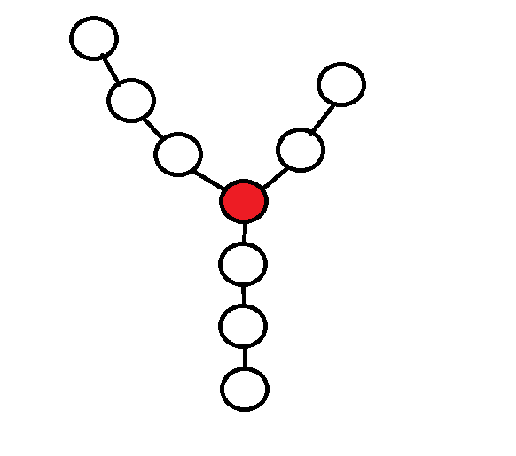

**HR Questions** (Mention below all the HR/Non-technical questions asked during the interview):

**GD/ JAM Topic:**

Any other tips for juniors: